**DAILY ONLINE ACTIVITIES SUMMARY**

|  |  |  |  |  |  |  |  |  |
| --- | --- | --- | --- | --- | --- | --- | --- | --- |
| **Date:** | **28-6-2020** | | | | | **Name:** | **Poojashree T** | |
| **Sem & Sec** | **8th sem B sec** | | | | | **USN:** | **4al16cs064** | |
| **Online Test Summary** | | | | | | | | |
| **Subject** | | **No Test** | | | | | | |
| **Max. Marks** | |  | | **Score** | | |  | |
| **Certification Course Summary** | | | | | | | | |
| **Course** | **Introduction to R language tutorial** | | | | | | | |
| **Certificate Provider** | | | **Great learning academy** | | **Duration** | | | **3.0hr** |
| **Coding Challenges** | | | | | | | | |
| **Problem Statement:** **1**. **to read the number and compute the series.**  **2. to count the number in th series.**  **3. to check whether number is palindrome or not.**  **4. to find the number between 0 and 50 which are not divisible by 2 and 3.**  **5.micro and array update**  Top of Form | | | | | | | | |
| **Status:completed** | | | | | | | | |
| **Uploaded the report in Github** | | | | | **yes** | | | |
| **If yes Repository name** | | | | | **Poojatgowda** | | | |
| **Uploaded the report in slack** | | | | | **yes** | | | |

**Online test**

**No Test**

**Certification course**

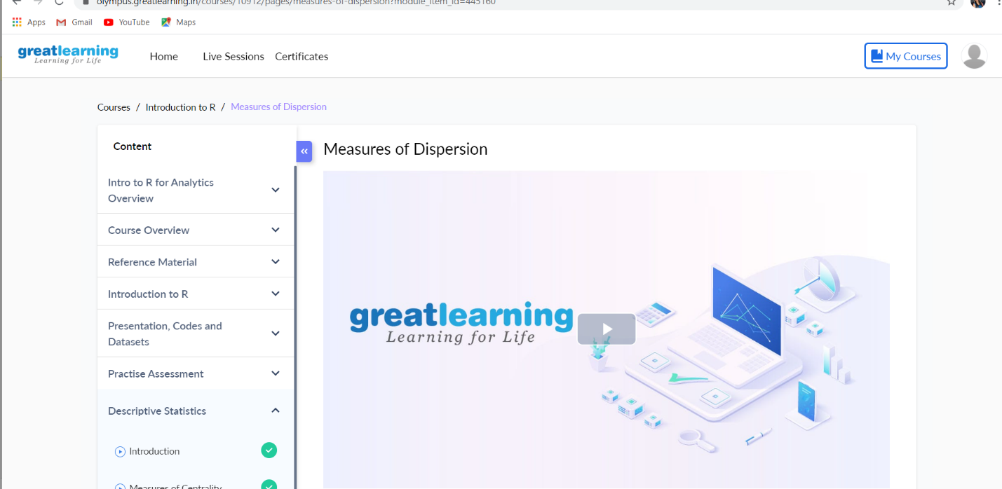

**Example: Program to check whether input number is prime or not**

To understand this program you should have the knowledge of [for loop](https://beginnersbook.com/2015/03/for-loop-in-java-with-example/), [if-else statements](https://beginnersbook.com/2017/08/if-else-statement-in-java/) and [break statement](https://beginnersbook.com/2017/08/java-break-statement/).

import java.util.Scanner;

class PrimeCheck

{

public static void main(String args[])

{

int temp;

boolean isPrime=true;

Scanner scan= new Scanner(System.in);

System.out.println("Enter any number:");

//capture the input in an integer

int num=scan.nextInt();

scan.close();

for(int i=2;i<=num/2;i++)

{

temp=num%i;

if(temp==0)

{

isPrime=false;

break;

}

}

//If isPrime is true then the number is prime else not

if(isPrime)

System.out.println(num + " is a Prime Number");

else

System.out.println(num + " is not a Prime Number");

}

}

Output:

Enter any number:

19

19 is a Prime Number

Output 2:

Enter any number:

6

6 is not a Prime Number